Test Sections
Multiple Choice: 40 points
- 20 questions at 2 point each
- 20 minutes

Sentence Revision 24 points
- 6 questions at 4 points each
- 15 minutes

Sentence Diagrams: 18 points
- 3 diagrams at 6 points each
- 20 minutes

Sentence Creation: 18 points
- 6 questions at 3 points each
- 10 minutes

I like cake; I like ice cream.
I like cake; also, I like ice cream.
I like cake. And, I like ice cream (happens but prescriptively wrong)
I like cake. While, I eat ice cream (totally incorrect)
Tommy likes cake although I like ice cream.
While I like ice cream, Tommy prefers cake.

I think he smells although I kind of do like him though.
I think he smells although I do kind of like him. He has this faint scent of beef. It’s kind of nauseating.

Section A: Multiple Choice
Section A1: Coordination and Subordination
Question One
Question One: Which of these is a simple sentence containing only one clause? (2 pts)
Answer:
- When he woke up, Steven was already late for school.
- He overslept because the alarm didn’t go off.
- On top of all that, Steven forgot his bookbag and was extremely late to class.
- None of it was his fault, and that is so unfortunate.

Question Two: Which of these is a Compound sentence containing two independent clauses? (2 pts)
Answer:
- Anthropologists study the human condition and often embed themselves deeply in the local context.
- They study workplace culture in wealthy urban areas, small communities in favelas in developing countries, and remote tribes of hunter-gatherers
- They always aim to be ethical, and direct impacts on the community are avoided.
- If they do negatively affect the community, the case is carefully documented.

Question Three: Which of these is a Complex sentence containing a dependent clause? (2 pts)
Answer:
- I went for a bicycle ride this weekend just because.
- I am hoping to complete a triathlon, but I am not sure when.
- My weakest event is the running portion, so I will need to really practice.
- I feel confident about the race if my knees can handle the pressure.

Question Four: Which of these sentences is punctuated correctly (following the strictest prescriptive rules)?
Answer:
- I never buy expensive clothes, because I grew up super poor.
- I grew up super poor and I never buy expensive clothes.
- Because I grew up super poor, I never buy expensive clothes.
- I never buy expensive clothes since I grew up super poor.

Question Five: Which of these sentences is punctuated correctly (following the strictest prescriptive rules)?
Answer:
- I started a doctoral program in 2012, however, I did not complete it.
- I started a doctoral program in 2012, however I did not complete it.
- I started a doctoral program in 2012 however I did not complete it.
- I started a doctoral program in 2012. However, I did not complete it.

Question Six: Which of these sentences is punctuated correctly (following the strictest prescriptive rules)?
Answer:
- Summer is a great time of year, yet it always makes me melancholy.
- Summer is a great time of year; yet, it always makes me melancholy.
- Summer is a great time of year. Yet, it always makes me melancholy.
- Summer is a great time of year yet it always makes me melancholy.

Question Seven: Which of these best describes the tense of the following sentence? (2 pts)
Sentence: My mother was happy until her divorce.
Answer:
- Present Tense
- Future Tense
- Past Tense
- No Tense (Modal)

Question Eight: Which of these best describes the aspect of the following sentence? (2 pts)
Sentence: I will be improving my grammar steadily this semester.
Answer:_____
- Simple Aspect
- Progressive Aspect
- Perfect Progressive Aspect
- Perfect Aspect

Question Nine: Which of these sentences is written in Present Perfect Progressive (Present Tense, Perfect Progressive Aspect)? (2 pts)
Answer:_____
- I have been throwing frisbees.
- I had been throwing frisbees
- I was throwing frisbees
- I have thrown frisbees.

Question Ten: Which of these sentences is in simple present (Simple Aspect, Present Tense)? (2 pts)
Answer:_____
- I had a cake.
- I do like that cake.
- I was packed up.
- He has been sleepy.

Section A2: Voice: 3 questions
Question Eleven: Which of these sentences is in passive voice? (2 pts)
Answer:_____
- My idea was very impressive.
- My idea had been impressing people.
- My idea was approved.
- My idea is bothering me.

Question Twelve: Which of these sentences is in active voice? (2 pts)
Answer:_____
- Bob has been by the sea all day.
- The proposal will be endorsed.
- Steven could have been thrown out a window.
- I was bothered by that last statement.

Question Thirteen: Which of these sentences correctly transforms the active voice sentence below into passive voice (while maintaining all other elements)? (2 pts)
Sentence: I certainly would not have approved that decision.
Answer:_____
- That decision certainly would not have been approved.
- That decision did not get approved.
- That decision was not approved.
- That decision certainly would not be approved.

Question Fourteen: Which of these sentences correctly transforms the passive voice sentence below into active voice (while maintaining all other elements)? (2 pts)
Sentence: The building plan has been approved by the inspector.
Answer:_____
- The inspector has been approving the building plan.
- The inspector has approved the building plan.
- The inspector approved the building plan.
- The inspector had approved the building plan.

Question Fifteen: Which of the sentences below does NOT include a modal? (2 pts)
Answer:_____
- I never have changed my will.
- I might know how to do the can-can
- I must be me.
- I shall study very hard.

Question Sixteen: Which of the sentences below does NOT include a modal? (2 pts)
Answer:_____
- I shall never falter.
- A can of beans is my favorite snack.
- I really couldn’t say.
- This poem may be my magnum opus.

Question Seventeen: Which of the sentences below does NOT include an auxiliary verb? (2 pts)
Answer:_____
- I do believe in ghosts.
- Poppies have put them to sleep.
- Dorothy has no ruby slippers.
- The witch will be getting crushed under a house.

Question Eighteen: Which of the sentences below DOES include an auxiliary verb? (2 pts)
Answer:_____
- I never was so sorry.
- I did the best I could.
- My in-laws have several jet-skis in their garage.
- Sarah’s cookies were eaten by mistake.

Question Nineteen: Which of the sentences includes BOTH a modal AND an auxiliary verb? (2 pts)
Answer:_____
- I couldn’t have another bite.
- My sister’s casserole wasn’t all that great.
- We won’t [will not] be taking any leftovers home with us.
- My sister might be sad though.

Question Twenty: Which of the sentences includes NEITHER a modal NOR an auxiliary verb? (2 pts)
Answer:_____
- I really have a problem.
- I didn’t think about my actions.
- I couldn’t be more sorry.
- It will take time for you to forgive me.

Section B:
Sentence Revision
Question Twenty One:
Revise this sentence by transforming it to Past Perfect (Past Tense, Perfect Aspect).
Sentence: I am afraid of ghosts.
Answer: I had been afraid of ghosts.
Question Twenty Two:
Revise this sentence by transforming it to Present Progressive (Present Tense, Progressive Aspect).
Sentence: I could have communicated more clearly.
Answer: I am communicating more clearly.
Question Twenty Three:
Revise this sentence to change the voice from Active to Passive. Maintain the original tense and aspect in the new sentence.
Sentence: All last month, the scientists were processing this new information.
- Past, progressive aspect

Answer: All last month, this new information was being processed by the scientists.

Question Twenty Five:
Revise this sentence to change the voice from Active to Passive. Maintain the original tense and aspect in the new sentence.
Sentence: Peter Sellers played nearly every main character in the film, The Mouse that Roared.
- Tense, Aspect

Answer: In the film, The Mouse that Roared, nearly every main character was played by Peter Sellers.

Questions Twenty Six:
Combine the two sentences below by adding a coordinating conjunction to form a compound sentence. Be sure to punctuate the new sentence correctly.
Sentence: Scientists at the University of Hawaii taught a pod of dolphins to communicate. All the dolphins died suddenly of a mysterious illness.
Scientists at the University of Hawaii taught a pod of dolphins to communicate, but all the dolphins died suddenly of a mysterious illness.
Question Twenty Seven:
Combine the two sentences below by adding a subordinating conjunction to make one a dependent clause. Be sure to punctuate the new sentence correctly.
Sentence: You are ill. You should go home.
Since you are ill, you should go home.

Section C: Sentence Creation
For section D and the Bonus, please write all the new sentences about a movie, book, or TV show you like. Feel free to reuse the same ideas and characters from the movie, book, or TV show as many times as you like. Feel free to copy from/mirror your earlier sentences in this activity. Be sure to punctuate the sentences correctly!
Name the movie, book or TV show here:___________________

Question Twenty Eight: (3 points)
Write a sentence containing this element:
- A coordinating conjunction connecting two clauses

Question Twenty Nine: (3 points)
Write a sentence containing this element:
- A dependent clause with a subordinating conjunction

Question Thirty: (3 points)
Write a sentence containing this element
- A passive voice verb phrase in past tense

Question Thirty One: (3 points)
Write a sentence containing this element
- A verb in past perfect progressive

Question Thirty Two: (3 points)
Write a sentence containing this element
- A simple sentence containing two noun phrases connected by a conjunction.

Question Thirty Three: (3 points)
- “Did” as an auxiliary verb

Sentence Diagrams: 18 points (3 diagrams, 6 points each)
On the following pages, you will find three sentences. Each sentence is worth six points.
Complete a diagram in the style we have been practicing. Please draw the diagrams by hand or using the digital tool on our Canvas page. I will grade generously, and I am not extremely concerned about the specific codes you use, so long as you label things clearly and structure the tree accurately. I am concerned that you draw the lines to the appropriate “level” on the diagram.
- Please be sure to include a node for each phrase (NP, VP, ADJP, ADVP, PP). When needed, please include an additional Clause (S) level to indicate sentences with coordination or subordination.
- When needed, please include an additional phrase level to indicate a complex phrase substituting for a different function. For instance, if you have a verb phrase (form) serving as a subject (function), diagram it as NP-VP-V.

I have provided five empty pages in the back of the exam if you need them for corrections or practice. Please just clearly indicate which is your final answer!

Question Thirty Four: Please diagram this sentence. (6 pts)
Sentence: When bad weather has been predicted, I always carefully watch the news.
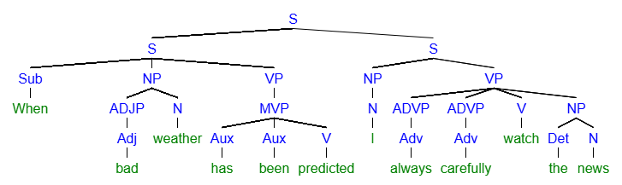
[S [S [Sub When] [NP [ADJP [Adj bad]] [N weather]] [VP [MVP [Aux has] [Aux been] [V predicted]]]] [S [NP [N I]] [VP [ADVP [Adv always]] [ADVP [Adv carefully]] [V watch] [NP [Det the] [N news]
Question Thirty Five: Please diagram this sentence. (6 pts)
Sentence: Sentence: After the meeting, many employees were given a promotion, and some were terminated.
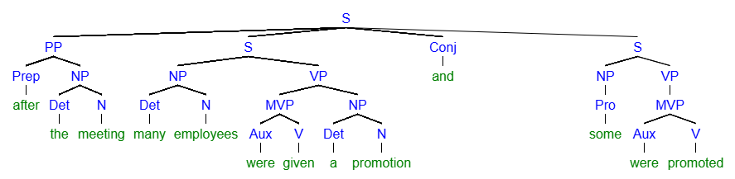
[S [PP [Prep after] [NP [Det the] [N meeting]]] [S [NP [Det many] [N employees]] [VP [MVP [Aux were] [V given]] [NP [Det a] [N promotion]]]] [Conj and] [S [NP [Pro some]] [VP [MVP [Aux were] [V promoted]
Question Thirty Six: Please diagram this sentence. (6 points)
Sentence: Gerlad could have been a millionaire but foolishly squandered his inheritance on trifles.
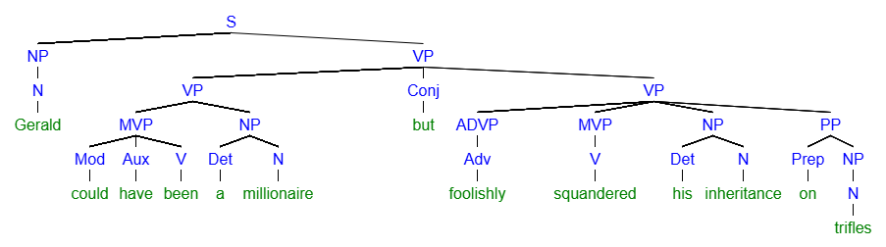
[S [NP [N Gerald]] [VP [VP [MVP [Mod could] [Aux have] [V been]] [NP [Det a] [N millionaire]]] [Conj but] [VP [ADVP [Adv foolishly]] [MVP [V squandered]] [NP [Det his] [N inheritance]] [PP [Prep on] [NP [N trifles]
Bonus: 2 Questions, Twelve Points
Bonus Question One: 6 points
Rewrite the following passage by transforming all the sentences to passive voice past tense (please maintain the aspect).
- You can choose to leave Marcus in the sentences or remove him.

Marcus measures the liquid chemicals carefully and pours them into a clean beaker. He lights the Bunsen burner and applies the flame to heat the solution gently. As the mixture reacts, he records the color change and rising temperature in the lab notebook. He then stirs the solution with a glass rod to ensure even mixing. Finally, he cleans the equipment and labels the sample for further analysis.
The liquid chemicals were carefully measured and poured into a clean beaker. The Bunser burner was lit and the flame was adjusted to the heat solution gently. As the mixture reacted, the color change and rising temperature were recorded in the lab notebook. The solution was stirred with a glass rod to ensure even mixing. Finally, the equipment was cleaned and the samples were labeled for further analysis.

Bonus Question Two: 6 points
Rewrite the following passage into active voice indicating that events will happen in the future (please maintain the aspect).
- Since the passive voice passage does not indicate the actor, please use yourself as the “actor/subject” of the new sentences.

A job was sought after graduation. Resumes were written and tailored for each position of interest. Applications were submitted to publishing houses, marketing firms, and nonprofit organizations. Interviews were scheduled and attended with careful preparation and enthusiasm.
I will seek a new job after graduation. I will write a resume and tailor it for each position of interest. I will submit applications to publishing houses, marketing firms, and nonprofit organizations. I will schedule interviews and attend them with careful preparation and enthusiasm.

